**Antique Art Nouveau Brass Table Mirror or Picture Frame**

**Price: $567**

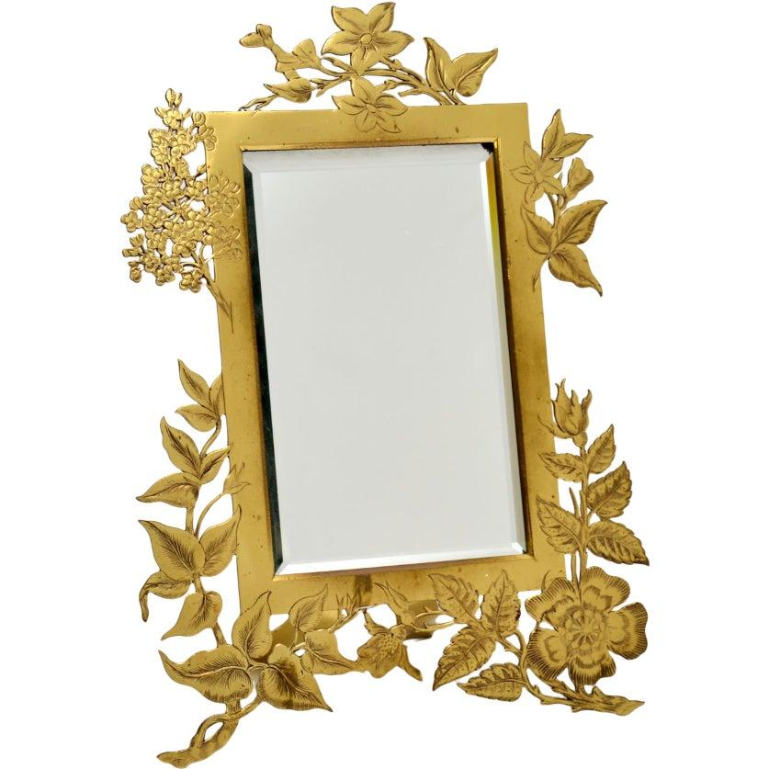

* CATEGORIES

Bathroom mirrors

* MATERIALS

Acrylic Bordered

* SHAPE

Rectangle

* BRAND

Viglacera